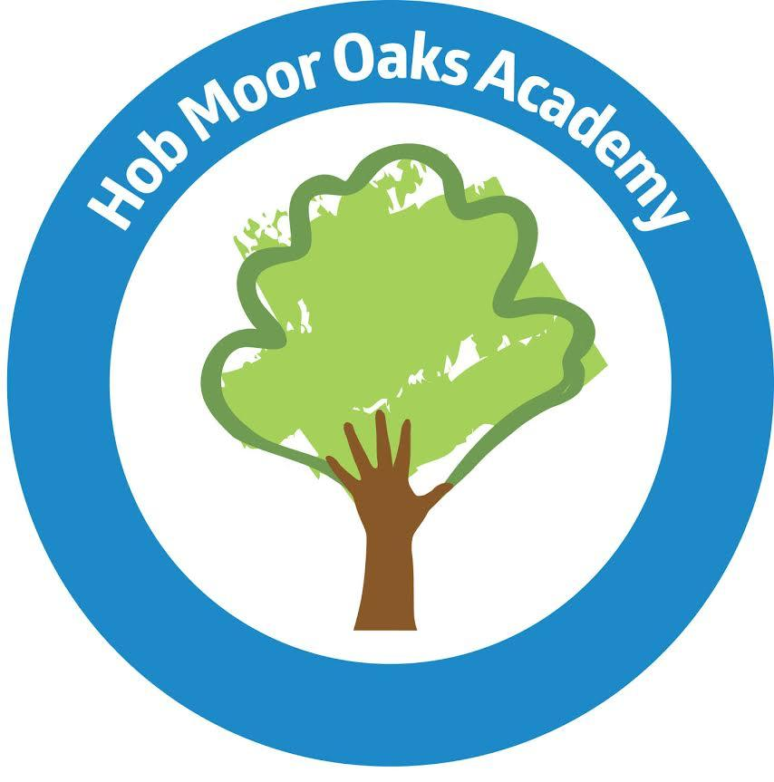
Welcome to
Hob Moor Oaks Academy

SEND Local Offer
(SEND Information Report)
2023-2024

About our school
Hob Moor Oaks is a special primary academy providing education for children who have significant special educational needs. We serve the City of York community and welcome children from neighbouring local authorities whose special educational needs can be met in this setting and who can travel to and from school in under an hour.

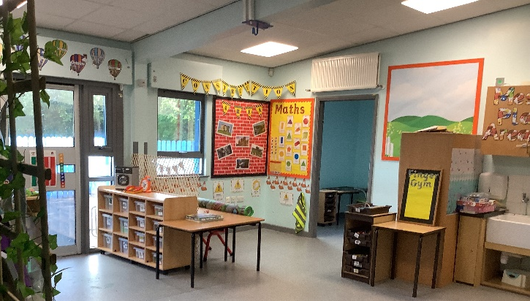
Come and have a look around…
We love to meet prospective pupils and their parents. Please get in touch to make an appointment to have a look around and meet some of our staff and children. Our show rounds are booked via our administration team and get booked up in advance. You are welcome to bring a friend, relative or supporter. It might be best not to bring your child with you at this stage as it could be confusing for him/her to see several schools.
You can also contact SENDiASS (Special Educational Needs and Disability Information, Advice and Support Service) to talk about your options. SENDiASS is part of the local authority’s Family Information Service. They provide impartial support, advice and information for parents and carers of children with special educational needs. You can easily contact the team on yorkSENDIASS@york.gov.uk. They work alongside a number of our parents offering advice and support for children whose needs are complex.
You can also find out more about the York Local Offer for children with SEND at: https://www.yor-ok.org.uk/families/Local%20Offer/sendlocaloffer

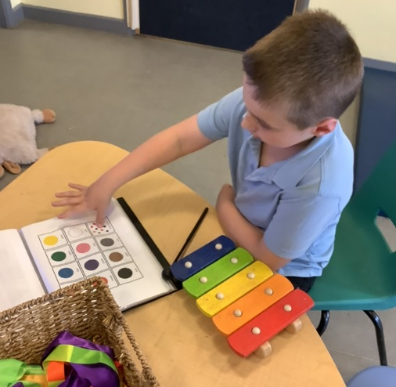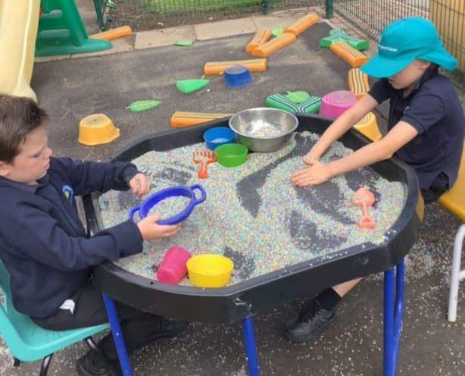

Admissions
Admissions to Hob Moor Oaks are dealt with on an individual basis by the local authority. Children who attend Hob Moor Oaks will have an Education Health and Care plan (SEND CoP 2014). We admit children from the age of 2 years old into our nursery provision. There are four main routes for admission to Hob Moor Oaks Academy.
1. Children with special educational needs are identified and assessed following the procedures in the SEN Code of Practice 2001/SEND Code of Practice 2014. If a child’s needs would be best catered for in a special school setting the local authority SEN caseworker will request a placement for your child at Hob Moor Oaks. The Headteacher will look at the paperwork and inform the local authority whether we are able to offer a place. The caseworker will then write to you to offer a place for your child. Your child will only be admitted if the school believes it can meet his/her special educational needs. Due to limited movement during the academic year, our transition takes place during summer term for a September start date.
2. When a child with an EHCP arrives from another area, parents may request a place at Hob Moor Oaks. The Head teacher will redirect the request to the SEN Designated Officer. The same procedure described above will be followed.
3. Children who live outside of York and have an EHCP may attend Hob Moor Oaks Academy at the discretion of the ‘home’ local authority. Request for places should be made as in paragraph 1 or 4 according your particular circumstances.
4. Sometimes the parents of a child who attends a local mainstream school may request a transfer to Hob Moor Oaks. This would be requested through the annual or interim review of his/her EHCP.

Transition arrangements
Once your child receives confirmation of their placements we will send you an admissions pack to complete. This will allow us to collect information about medical needs, communication preferences, transport requirements etc…
We will then visit you and your child (either in their school setting or at home) to talk about transition and draw up a plan which will meet their needs. Some of our pupils start with single days/sessions and build-up gradually over time.
Some cope best with a clear move and preparation for new routines. We know that preparing to start school, or move to a new school can be a stressful time for parents and their children. Our main aim for parents is to develop an positive working relationship based on trust. We feel proud of the positive and trusting relationships we have with our existing parents.
Before your child starts at HMO we hope that you will visit or communicate with us as often as you need to gather the information that you need. Our main aim on transfer is to make your child feel safe and to ensure your child is happy. Learning will follow as soon as these are secured.
Part time placements
Part time placements are available up until the term after your child’s 5th birthday. Parents are always advised children may not be able to access all our specialist resources on dual or part time placements.
Dual placements
Some children benefit from a dual placement with their local mainstream school. We will consider requests for dual placements for a minimum of 3 days at HMO and 2 days in mainstream. Parents are always advised children may not be able to access all our specialist resources on dual or part time placements.
Home to School Transport
The local authority may provide transport for children who have an EHCP with Hob Moor Oaks as the named school. We aim to work in partnership with families, transport providers and the local authority to ensure that the journey to and from school is a positive experience which contributes to the child’s learning.
At Hob Moor Oaks we co-produce an Individual Travel Plan with parents, for every child who uses Home to School Transport. This will be shared with your permission, with the driver and escort who bring your child to school.
Every child has a named person who supervises their transfer from the vehicle into the classroom. This could be a driver, personal transport assistant (PTA) or teaching assistant. Parents/carers who bring their child to school are encouraged to drop their child at our main foyer to be greeted by a member of staff. We aim to make every child as independent as possible.
Keeping in touch
When your child attends a special school you may worry about how to keep in touch about his/her daily routine. We try very hard to ensure you don’t feel isolated. The class teacher will be your main point of contact.
- Every child will have an electronic learning journey (called ‘Tapestry’) to enable parents and carers to see the educational progress their child is making. Within this online journal there is a ‘Care Diary’, this is how we communicate daily with our parents/carers and school staff check this every morning and afternoon.
- Class teams write a weekly ‘Memo’ on Tapestry to share the weekly learning, this is to ensure our learning observations remain purposeful and ‘remark on the remarkable’.
- We write a weekly newsletter to let you know what is happening in school.
- Each class writes a half termly newsletter to share what they will be learning about in the next few weeks including the curriculum timetable.
- We encourage all our parents to share and upload weekend learning experiences via Tapestry.
- On our half termly newsletters, we include home learning opportunities that you can do with your child and we include key words, signs and symbols.
- Reading books will be sent home to children who are ready to generalise their reading skills between school and home.
We hold parent/carer consultation meetings every term and your child will have an interim 6 monthly review up to the age of five and then an annual review of their EHCP.
Our office staff will always try to help if you call in or ring school. Teachers are not generally available during lessons times however messages are picked up regularly. We will always find someone to help you if your call is urgent to you.
Parents receive our Communication Leaflet at the start of the school year which informs you of all the ways in which we communication with each other including Apps from our Admin team.
We conduct regular satisfaction surveys based on a range of aspects including communication; pupil voice; behaviour; curriculum.
Olivia Hargreaves the Headteacher can be contacted on: o.hargreaves@ebor.academy

Times of Day
Mornings: 08.50 - 11.45
Break: 10.30 - 10.45 or 10:45 to 11:00
Afternoons: 13.00 - 15.20

Working in Partnership with Parents and Carers
We recognise that parents/carers are the experts about their own children. We aim to work in partnership with families to ensure that your child can be the very best they can be.
Our class teachers will be your main point of contact. Teachers are supported by our Wellbeing Team (WEB); health team and admin team to ensure that you and your family are sign posted to the most appropriate services.
When things go wrong
Communication is at the heart of everything we do. We are always striving to improve the service we provide. Within our relationships we hope that parents will feel confident that their voice will be listened to. We urge parents to let us know if they are unhappy about any aspect of their child’s school experience.

Our class groups
We have 14 classes at Hob Moor Oaks; they all have names which relate to the oak tree.
We try to put groups of children together who are of a similar age and who are likely to learn well together. Our class groups are small, with high staffing ratios. Each class has a teacher and at least two teaching assistant; the majority of classes have three teaching assistants.
We also have midday care assistants who work alongside the class team to support children to have their lunch, play and with personal care.

Class Groups 2023-2024
 | Seedlings  2023-24 N2-Y1 | 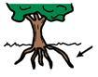 | Roots (Autism)  2023-24 Y2-Y4
 | Blossoms (Autism)  2023-24 Rec-Y1 | 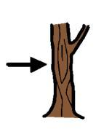 | Trunks  2023-24 Y3-Y6
 | Green Shoots (Autism)  2023-24 Rec-Y2 |  | Boughs (Autism)  2023-24 Y2-Y4
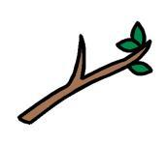 | Twigs  2023-24 Y1-Y3 |  | Catkins (Autism)  2023-24 Y4-Y6
 | Saplings  2023-24 Y2-Y4 |  | Woods  2023-24 Y3-Y6
 | Buds (Autism)  2023-24 Rec-Y2 |  | Oak Leaves  2023-24 Y4-Y6
 | Branches (Autism)  2023-24 Y1-Y2 |  | Oak Trees (Autism)  2023-24 Y4-Y6

Our learning environment
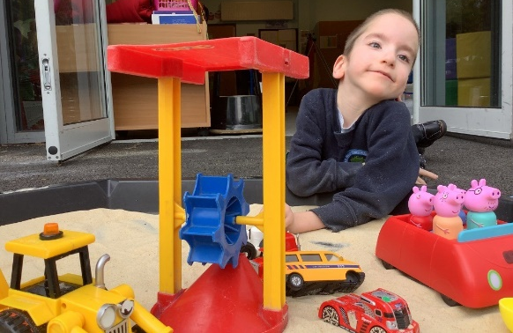
Hob Moor Oaks is part of the Federation with Hob Moor Community Primary Academy. We can have upwards of 400 children and over 100 staff on site. On paper it sounds like a very busy place.
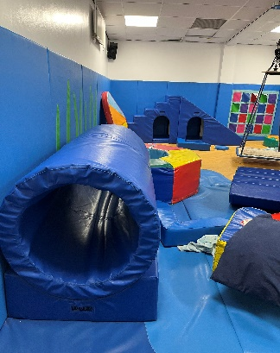
We pride ourselves in providing a safe, calm and happy learning environment. In the Oaks we offer a range of learning environments which help to address the child’s barriers to learning. We have spacious classrooms with ceiling tracking hoists and accessible changing facilities. We also have compact classrooms with small side rooms which can offer a continuum of low stimulation accommodation. We use a range of standard and specialised classroom furniture which addresses individual children’s barriers to learning.
All of the Oaks classrooms have toilet facilities and kitchen areas. Hob Moor Oaks has a range of specialist facilities including a hydrotherapy pool, soft play room, sensory theatre and white room.
Personalised learning and care
At Hob Moor Oaks Academy we see every child as a unique child. We offer a personalised package of learning and care to ensure that your child can be the very best they can be.
Individual learning intentions are written and reviewed at least three times a year. Moving and Handling plans are written for those children who need help to move. You will be involved in writing and reviewing all plans so that your priorities for your child are reflected in our planning.
All of our staff are trained in the safeguarding of vulnerable learners, moving and handling and intimate care procedures.
The curriculum
We deliver an exciting experiential specialist curriculum which is based around the stages of development (birth – 7 years approximately). Classes are grouped into a phase to support a balanced curriculum, each phase has a phase leader driving improvement and excellence.
Orchard Phase Woodland Phase Forest Phase

Our topic based creative curriculum has an overarching theme that enables our school to offer inclusive opportunities that are differentiated to the needs of our unique pupils.
Our overarching themes for the next two years are:-
Autumn 1 (2023-24) | Healthy me | My Friends | Helping hands
Autumn 2 | Winter wonderland | Snow globe | No business like snow business!
Spring 1 | Are we nearly there yet? | Holidays | Beyond the sea
Spring 2 | Splish Splash | Mix it up | Shine a light
Summer 1 | Survival | Grow your own | Animal Kingdom
Summer 2 | “I like to move it, move it..” | Rocking all over the world | How my body can move
Autumn 1 (2024-2025) | On the High Street | The grand old duke of York | Life before me
Autumn 2 | The Chill Factor | Arctic Explorers | Frostbite
Spring 1 | Journeys | Out of this world | Ticket to ride
Spring 2 | Messmakers (senses) | Colour of magic | How to?
Summer 1 | We are on the move | Market place | Farm to fork
Summer 2  Enterprise - (Summer Fair) | Sound of Summer | Celebrations | Together everyone achieves more

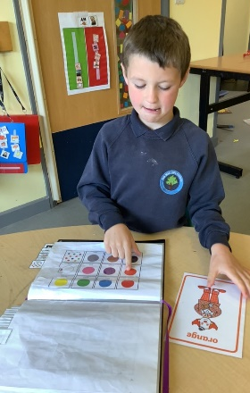
Our total communication approach
At Hob Moor Oaks we believe that communication underpins all learning. We aim to create a Total Communication environment which will be appropriate to the needs of individual pupils and will consistently be supported by all staff. This means pupils are encouraged to use all available and appropriate forms of communication to enable them to become independent and effective communicators.
Within Hob Moor Oaks School every area of the curriculum subject policy is underpinned by a Total Communication ethos in order to enable each child to access the tools of communication that are most relevant for him or her.
These may include any combination of the following communication strategies: body language, facial expression, vocalisation, objects of reference, photographs, symbols/drawing, signing, the spoken word and access to technology.
The knowledge and skills taught through the Communication Language and Literacy curriculum support access to all other areas of the curriculum. The teaching of communication, reading and writing is reinforced and embedded throughout all curriculum subjects through the use of key subject vocabulary and key thematic vocabulary.
Some pupils will require an augmentative and assistive communication system (AAC) to support their natural speech, for others an augmentative communication system will be their main mode of communication. Some pupils may have a lifelong need for AAC; others may need AAC as an interim strategy whilst they develop their language and communication skills.
Total communication strategies will promote the development of pupil’s skills in expressing personal needs, commenting, refusing, questioning, sharing information, directing others, indicating choices, developing imaginative play, telling jokes etc.
Pupils should be encouraged and supported to develop and use their functional communication skills in the same way as natural speech is used by others, in practical and varied situations.

Relationship and sex education
"Special schools have a particularly sensitive role to play. Children with learning difficulties are entitled to the same opportunity as other children to benefit from sex education. They may need more help than others in coping with the physical and emotional aspects of growing up, they may also need more help in learning what sort of behaviours are, and are not, acceptable, and in being warned and prepared against unacceptable behaviour in adults." DfE 5/94
At Hob Moor Oaks we believe that relationship and sex education is an essential aspect of the curriculum, including online safety. It empowers children and young people to form appropriate relationships and to be actively involved in their own safeguarding. Relationship and sex education is embedded into our personal, social, health and citizenship education.
We provide discreet units of work to all Year 5 & 6 pupils as they mature and approach puberty. This Sex Education work is undertaken jointly by class based staff and the nursing team using a range of specialist resources and will be discussed with parents in advance.
Religious education and assemblies
Hob Moor Oaks is a non-denominational school. We offer a curriculum which has a Christian ethos. RE is embedded in our creative curriculum where we explore relationships, symbolism, respect and understanding. We celebrate a range of multi-cultural religious festivals.
At Hob Moor Oaks Academy we have a weekly Celebration Assembly where children’s experiences, participation and achievements are celebrated. Pupils are nominated to receive a ‘Golden Leaf’ award by their class teams. Parents/carers are invited by text message to our Friday Celebration Assemblies when your child is receiving an award.
We also have a KS1 and KS2 assemblies which explore a weekly PSHCE ethos statement which reflects our Jigsaw PSHCE curriculum.
In addition to these assemblies, we also have open afternoons throughout year for parents to join us in creative activities these include; Christmas Art day; Mother’s Day; Father’s Day.
Be a Hob Moor Oaks ‘HERO’! (Here Every day Ready On time!)
Parents/carers receive an information booklet to help make the right decision as to when to keep your child at home if they are unwell. We aim to minimise the risk of cross infection by insisting that children stay at home for 48 hours after a vomiting and/or diarrhoea bug. We also request that children stay at home for the first 48 hours of any antibiotic treatment.
https://hobmooroaks.ebor.academy/wp-content/uploads/2022/06/Attendance-Guidance-and-Information-HMO-HERO-May-2022-.pdf
If your child becomes ill during the school day we will follow agreed procedures as set out in the child’s health care plan. Minor injuries will be treated by one of our trained First Aiders. Parents will be informed by telephone or in writing of any minor injuries.
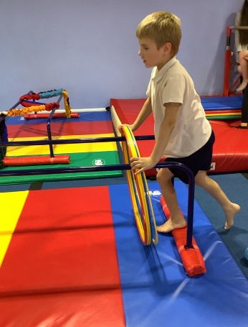
We aim to work in partnership with parents. Please let us know of any bumps or bruises which have occurred at home so that we can monitor your child appropriately.
Educational visits
We support our pupils in their development and preparation for life we offer a range of curriculum led school visits and will request a voluntary contribution when necessary. Visits may not go ahead if insufficient contributions are received. Several of our staff are qualified to drive our two school minibuses which are used for educational visits. Our educational visits are planned within our long term plan, ensuring there is development and progression through the learning phases (Orchard, Woodland and Forest).
Supporting Services
At Hob Moor Oaks we work closely with other services to ensure the holistic needs of your child are catered for within the school day. We welcome colleagues from York Teaching Hospital NHS Trust who hold regular clinics within school. This helps to minimise the disruption to a child’s school day and enables parents and carers to maintain regular contact with colleagues across all disciplines.
We also call on the expertise within the local authority from educational advisors, consultants and specialist teachers.
Occupational Therapy Team
Our occupational therapist is employed by York Teaching Hospital NHS trust and spends part of the week at Hob Moor Oaks and part of the week at Applefields School. The OT assesses children who may require specialist seating or equipment to develop their functional independence. The OT also advises class teams on approaches to use with individual children.
Our Covid Recovery Premium has enabled us to receive Sensory OT support for all pupils with a sensory processing difference. This has supported our staff teams to better support our pupils to access sensory diet plans, these activities include sensory circuits, access to the white room and sensory seeking resources such as exercise balls, chewy buddies and ear defenders.
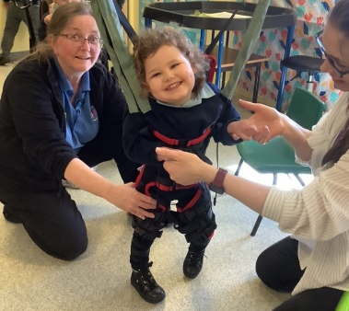
Physiotherapy Team
Our physiotherapist is also employed by York Teaching Hospital NHS trust and spends part of the week at Hob Moor Oaks School and part of the week working in the community. The physio also assesses individual children and recommends a physical management programme which can be integrated in the school day. The physio works very closely with the OT and the class teams to ensure all the child’s physical needs are addressed.
Speech and Language Therapy Team
Our SLT is also employed by York Teaching Hospital NHS trust. Children are assessed by the SLT who, in consultation with teaching colleagues, will jointly plan appropriate termly communication targets to be implemented throughout the school day. The school therapist has access to a wide range of specialist SLT colleagues who are all part of the York team.
Health Care Assistants and Special School Nursing Team
Hob Moor Oaks employ two dedicated Health Care Assistants to support the medical needs of our pupils across school. They work closely with NHS special school nurses (York Teaching Hospital NHS trust) who work as a team across Hob Moor Oaks. We have a nurse on site at all times. The health team administers medications and manages and advises on medical procedures including gastrostomy care, oxygen therapy, epilepsy, diabetes and any other health related conditions. All pupils with medical or health needs have a medical care plan, agreed by parents, school and medical professionals.
Specialist Teaching Team
Specialist teachers for Vision Impairment, Hearing Impairment work alongside school staff to share ideas and expertise. They also observe and monitor individual children’s progress as representatives of the local authority.

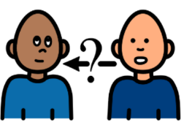
We hope that this booklet has helped to answer some of your questions. I’m sure you’ll have many more. Please feel free to contact us: 01904 806655 admin.hmo@ebor.academy
We look forward to meeting you soon, Olivia Hargreaves, Head teacher
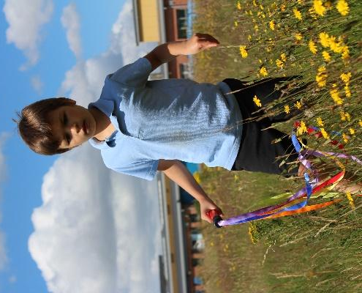
We aim to work in partnership with parents. Please let us know of any bumps or bruises which have occurred at home so that we can monitor your child appropriately.
Educational visits
We offer a range of out of school visits and will request a voluntary contribution when necessary. Visits may not go ahead if insufficient contributions are received. Several of our staff are qualified to drive our three school minibuses which are used for educational visits.
Supporting Services
At Hob Moor Oaks we work closely with other services to ensure the holistic needs of your child are catered for within the school day. We welcome colleagues from York Teaching Hospital NHS Trust who hold regular clinics within school. This helps to minimise the disruption to a child’s school day and enables parents and carers to maintain regular contact with colleagues across all disciplines.
We also call on the expertise within the local authority from educational advisors, consultants and specialist teachers.
Occupational Therapy Team
Our occupational therapist is employed by York Teaching Hospital NHS trust and spends part of the week at Hob Moor Oaks and part of the week at Applefields School. The OT assesses children who may require specialist seating or equipment to develop their functional independence. The OT also advises class teams on approaches to use with individual children.
Physiotherapy Team
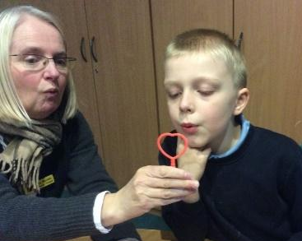
Our physiotherapist is also employed by York Teaching Hospital NHS trust and spends part of the week at Hob Moor Oaks School and part of the week working in the community. The physio also assesses individual children and recommends a physical management programme which can be integrated in the school day. The physio works very closely with the OT and the class teams to ensure all the child’s physical needs are addressed.
Speech and Language Therapy Team
Our SLT is also employed by York Teaching Hospital NHS trust. Children are assessed by the SLT who, in consultation with teaching colleagues, will jointly plan appropriate termly communication targets to be implemented throughout the school day. The school therapist has access to a wide range of specialist SLT colleagues who are all part of the York team.
School Health Nursing Team
Our Nurses and nursing assistants are employed by York Teaching Hospital NHS trust and work as a team across Hob Moor Oaks and Applefields School. We have a nurse on site at all times. The Nursing team administers medications and manages and advises on medical procedures including gastrostomy care, oxygen therapy, epilepsy, diabetes and any other health related conditions.
Specialist Teaching Team
Specialist teachers for Vision Impairment, Hearing Impairment, Autism, Physical and Medical Needs work alongside school staff to share ideas and expertise. They also observe and monitor individual children’s progress as representatives of the local authority.

We hope that this booklet has helped to answer some of your questions. I’m sure you’ll have many more. Please feel free to contact us: 01904 555000 admin.hmo@ebor.academy
We look forward to meeting you soon, Olivia Hargreaves, Head of School

